# CS 255 System Design Document Template

## UML Diagrams

### UML Use Case Diagram

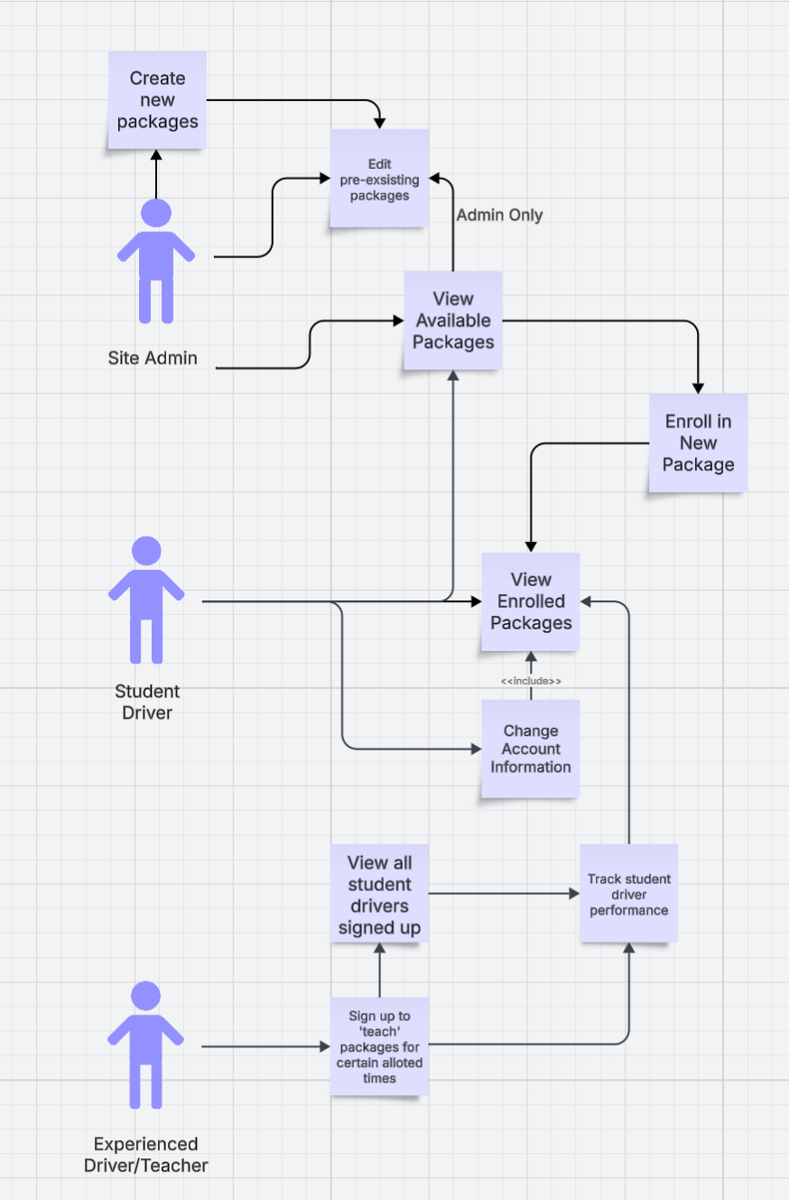

### UML Activity Diagrams

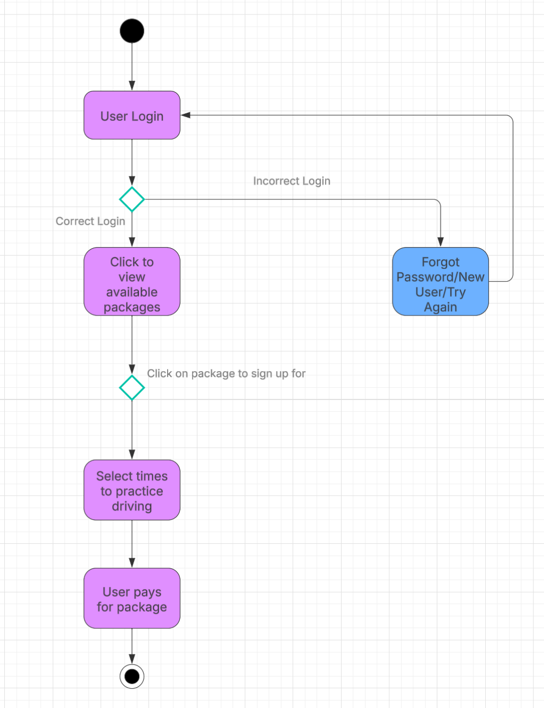

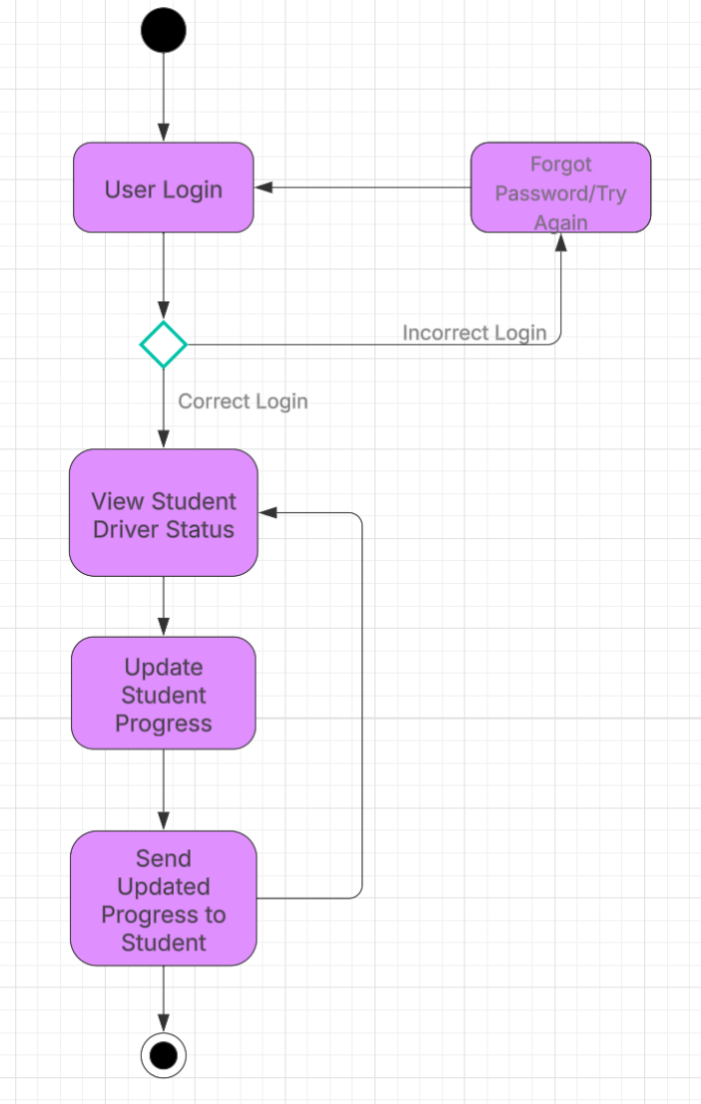

### UML Sequence Diagram

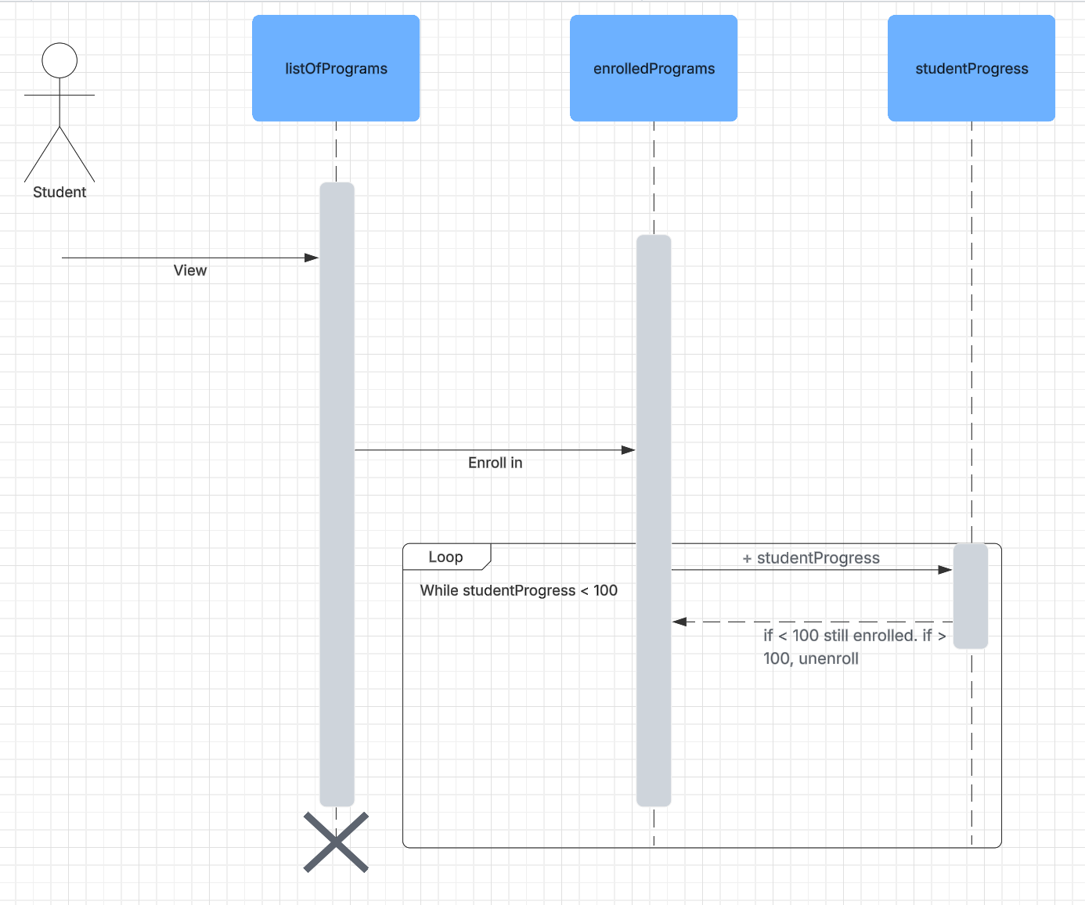

### UML Class Diagram

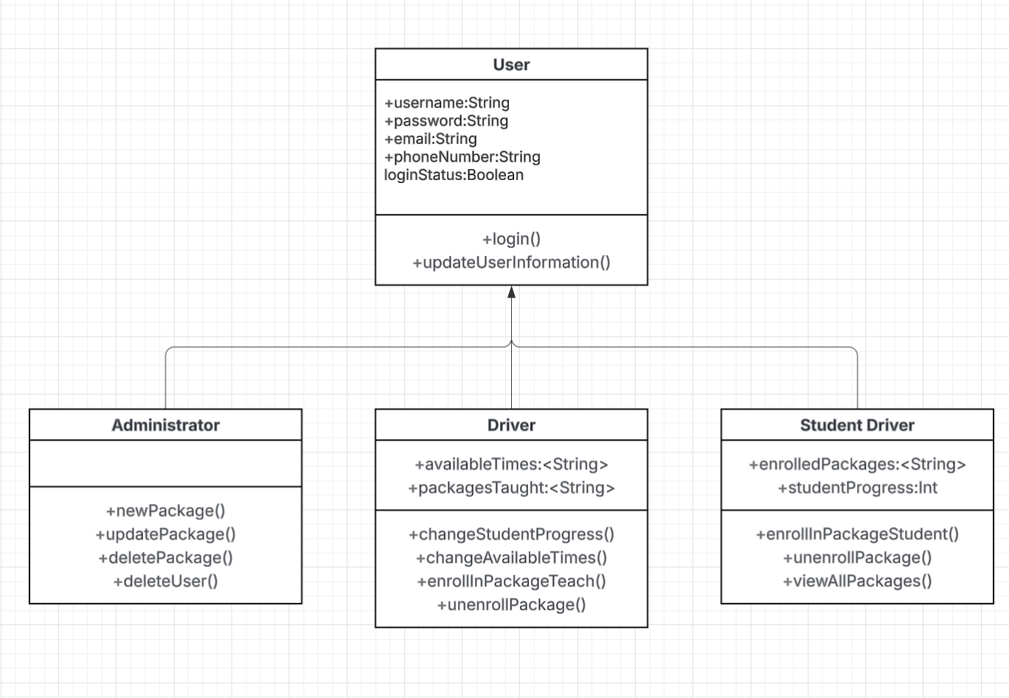

## Technical Requirements

The website for DriveTime will need a web host, google cloud is a good option, that should help the website with recognition in appearing in google searches. It also allows integration with java, which allows more dynamic websites to be made. Afterwards a domain name will need to be registered and a SSL certificate verified. The website will need search engine optimization to appear as high as possible in google searches. If operating through google cloud, the website can be coded using Java, and then a secure database could be created using mySQL and connected using Java Database Connectivity. The website should be optimized to run quickly and should contain accessibility features so as to appeal to the largest group of people. Accessibility features could include: screen reader accessibility (such as text description for images), high contrast text, the ability to shift the site into ‘dark mode’ (black background and off-white/grey text), and differing fonts (to help with dyslexic people’s reading).